Mouth Parts in Insects (With Diagram)
Mouth Parts in Insects!

1. Biting and Chewing:
This type of mouth parts are supposed to be the most primitive type as the other types are believed to be evolved from biting and chewing type of mouth parts.
These consist of the labrum forming upper lip, mandibles, first maxillae, second maxillae forming lower lip, hypo pharynx and the epipharynx.
The labrum is median, somewhat rectangular flap-like. The mandibles are paired and bear toothed edges at their inner surfaces; they work transversely by two sets of muscles to masticate the food. The first maxillae are paired and lie one on either side of the head capsule behind the mandibles. Each possesses a five-jointed maxillary palp which is a tactile organ.
The first maxillae help in holding the food. The second maxillae are paired but fused to form the lower lip. Its function is to push the masticated food into the mouth. The hypo pharynx is single median tongue-like process at whose base the common salivary duct opens. The epipharynx is a single small membranous piece lying under the labrum and bears taste buds.
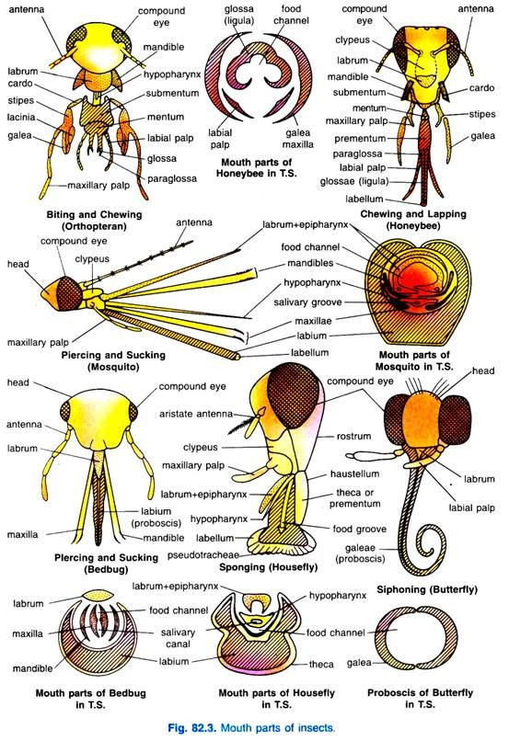
This type of mouth parts are found in orthopteran insects like cockroaches, grasshoppers, crickets, etc. These are also found in silver fish, termites, earwigs, beetles, some hymenopterans and in caterpillars of Lepidoptera.

2. Chewing and Lapping:
This type of mouth parts are modified for collecting the nectar and pollen from flowers and also for moulding the wax, as is found in honeybees, wasps, etc. They consist of the labrum, epipharynx, mandibles, first pair of maxillae and second pair of maxillae.
The labrum lies below the clypeus, below the labrum is a fleshy epipharynx which is an organ of taste.
Mandibles are short, smooth and spatulated, situated one on either side of the labrum; used in moulding wax and making the honeycomb. The labium (second pair of maxillae) has reduced paraglossae, the glossae are united and elongated to form the so called retractile tongue, at its tip is a small labellum or honey spoon. The labial palps are elongated.
The glossa is used for gathering honey and it is an organ of touch and taste. The first pair of maxillae are placed at the sides of labium, they bear small maxillary palps, lacinia is very much reduced but galea are elongated and blade-like.
The galea and labial palps form a tube enclosing the glossae which moves up and down to collect nectar from flower nectaries. The nectar is sucked up through the tube, so formed, by the pumping action of the pharynx. The labrum and mandibles help in chewing the food.

3. Piercing and Sucking:
This type of mouth parts are adapted for piercing the tissues of animals and plants to suck blood and plant juice, and found in dipteran insects like mosquitoes and hemipteran insects like bugs, aphids, etc.
They usually consist of labium, labrum and epipharynx, mandibles, maxillae (1st pair) and hypo pharynx.
However, for the sake of easy description, this type of mouth parts can be discussed in the following two headings:
(i) Piercing and sucking mouth parts of mosquitoes:
The labium is modified to form a long, straight, fleshy tube, called proboscis. It has a deep labial groove on its upper side. The labial palps are modified to form two conical lobes at the tip of the proboscis, called labella which bear tactile bristles. The labrum is long needle-like. The epipharynx is fused with the labrum. The labrum-epipharynx, thus, covers the labial groove dorsally from inside.
These structures appear C- shaped in transverse section having a groove, called food channel. Mandibles, maxillae and hypo pharynx are modified to form needle-like stylets which are placed in the labial groove. In male mosquitoes, the mandibles are absent. The mandibles are finer than the maxillae, but both have saw-like edges on their tips. The hypo pharynx possesses salivary duct which opens at its tip.
(ii) Piercing and sucking mouth parts of bugs:
In bedbug, the labium constitutes a three- jointed proboscis. The mandibles and maxillae are modified to form stylets; the mandibular stylets possess blade-like tips, while maxillary stylets possess saw-like tips. The labrum is flap like and covers the labial groove at the base only.
Of the four stylets, mandibles are placed externally in the labial groove, while both the maxillae are placed internally in the labial groove. The maxillae are grooved and placed in such a way that they form an upper food channel and lower salivary canal. The epipharynx and hypo pharynx are absent.

4. Sponging:
This type of mouth parts are adapted for sucking up liquid or semiliquid food and found in houseflies and some other flies. They consist of labrum- epipharynx, maxillae, labium and hypo pharynx; mandibles are entirely absent.
In fact, in this type of mouth parts, the labium, i.e., lower lip is well developed and modified to form a long, fleshy and retractile proboscis.
The proboscis is divisible into three distinct parts:
(i) Rostrum or basiproboscis; it is broad, elongated and cone-shaped basal part of proboscis articulated proximally with the head and bears a pair of un-jointed maxillary palps representing the maxillae,
(ii) Haustellum or mediproboscis; it is the middle part of proboscis bearing a mid-dorsal oral groove and a ventral weakly chitinised plate-like theca or mentum.
A double- edged blade-like hypo pharynx is located deep inside the oral groove; it bears salivary duct and closes the groove of labrum-epipharynx from below. The labrum-epipharynx is a long, somewhat flattened and grooved structure covering the oral groove. The food canal or channel is, thus, formed by labium-epipharynx and the hypo pharynx.
(iii) Labella or distiproboscis; it is the distal part of proboscis and consists of two broad, flattened and oval spongy pads having a series of channels called pseudo tracheae. These open externally by a double row of tiny holes through which liquid food is taken in. The pseudo tracheae converge into the mouth lying between the two lobes of labella which lead into the food canal.

5. Siphoning:
This type of mouth parts are adapted wonderfully for sucking flower nectar and fruit juice, found in butterflies and moths belonging to the order Lepidoptera of class Insecta. They consist of small labrum, coiled proboscis, reduced mandibles and labium. The hypo pharynx and epipharynx are not found.
The labrum is a triangular sclerite attached with the front clypeus of the head. The proboscis is formed by well-developed, greatly elongated and modified galeae of maxillae. It is grooved internally to form the food channel or canal through which food is drawn up to mouth. At rest, when proboscis is not in use, it is tightly coiled beneath the head but it becomes extended in response to food stimulus.
The extension of proboscis is achieved by .exerting a fluid pressure by the blood. Mandibles are either absent or greatly reduced, situated on the lateral sides of the labrum. The labium is triangular plate-like bearing labial palps.

